**HO CHI MINH CITY UNIVERSITY OF TECHNOLOGY AND EDUCATION**

**FACULTY FOR HIGH QUALITY TRAINING**

**-----------------⸙∆⸙-----------------**



**WEEKLY’S REPORT**

**TOPIC: Monitoring DC motor using SIMULINK**

**GVHD: Trần Đức Thiện**

**SVTH: Trần Minh Quân**

**MSSV: 19151078**

**Tp. Hồ Chí Minh 21 tháng 03 năm 2022**

Contents

1. Investigate the motor speed control model 2

1.1 Find a system of state variable equations describing a system with two state variables x1=i and x2= ω 2

1.2 From the system of equations found in question a, find the transfer function describing the motor with the input signal being the supply voltage and the output signal being the rotational speed of the motor (𝜔) with the assumption of ignoring the load torque (no idle running). load) 3

1.3 From the transfer function found in question b, design a PI controller according to the optimal modulus criterion 3

1.3.1 Carry out system survey with controller P ( kI = 0, kD = 0 ). Find the overshoot, steady-state error and transient time according to the following table 4

1.3.2 Carry out system survey with PI controller ( kp = 33,323, kD = 0 ). Find the overshoot, steady-state error and transient time according to the following table 4

2. Exercises 5

3. Simulation 5

3.1 Lesson 1 5

3.1.1 KI = 0, KD = 0 6

3.1.2 KP = 33,323, KD = 0 7

3.2 Lesson 2 7

Figure 1: Investigate transfer function with varying Kp 4

Figure 2: Investigate transfer function with varying Ki 4

Figure 3: PID control block diagram with state space 5

Figure 4: Output wave 5

Figure 5: System output wave when changing Kp and Ki=0,Kd=0 6

Figure 6: System output when changing Ki 7

Figure 7: Block diagram of DC motor 8

Figure 8: System output with Mc=0.01 8

# Investigate the motor speed control model

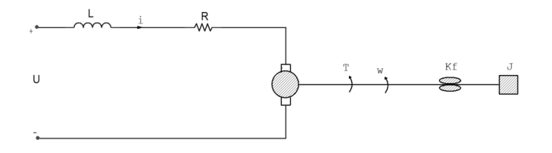

L: inductance of the stator winding.

R: resistance of the stator winding.

i: current flowing in the stator winding.

U: voltage supplied to the motor.

T: rotational torque.

𝜔: angular velocity.

𝐾𝑓: coefficient of friction.

𝐾𝑚: torque constant 𝐾𝑚.

𝐾𝑏: electromotive force constant 𝐾b.

J: moment of inertia of the moving parts.

Give R=2Ω, L=0.5H, Km = 0.015, Kb = 0.015Vs/rad, Kf = 0.2, J = 0.02kgm/s2

## Find a system of state variable equations describing a system with two state variables x1=i and x2= ω









From status variable x1=i(t) and, the state space equation is described as:







Matrix with R=2Ω, L=0.5H, Km = 0.015, Kb = 0.015Vs/rad, Kf = 0.2, J = 0.02kgm/s2.





## From the system of equations found in question a, find the transfer function describing the motor with the input signal being the supply voltage and the output signal being the rotational speed of the motor (𝜔) with the assumption of ignoring the load torque (no idle running). load)



Transfer function:



We have:









Transfer function:



## From the transfer function found in question b, design a PI controller according to the optimal modulus criterion

We have:



I guess: 

In there: < 

According to the optimal modulus criterion, the PI controller has the form:



### Surveying the system with P controller ( kI = 0, kD = 0 ). Find the overshoot, steady-state error and rise time.

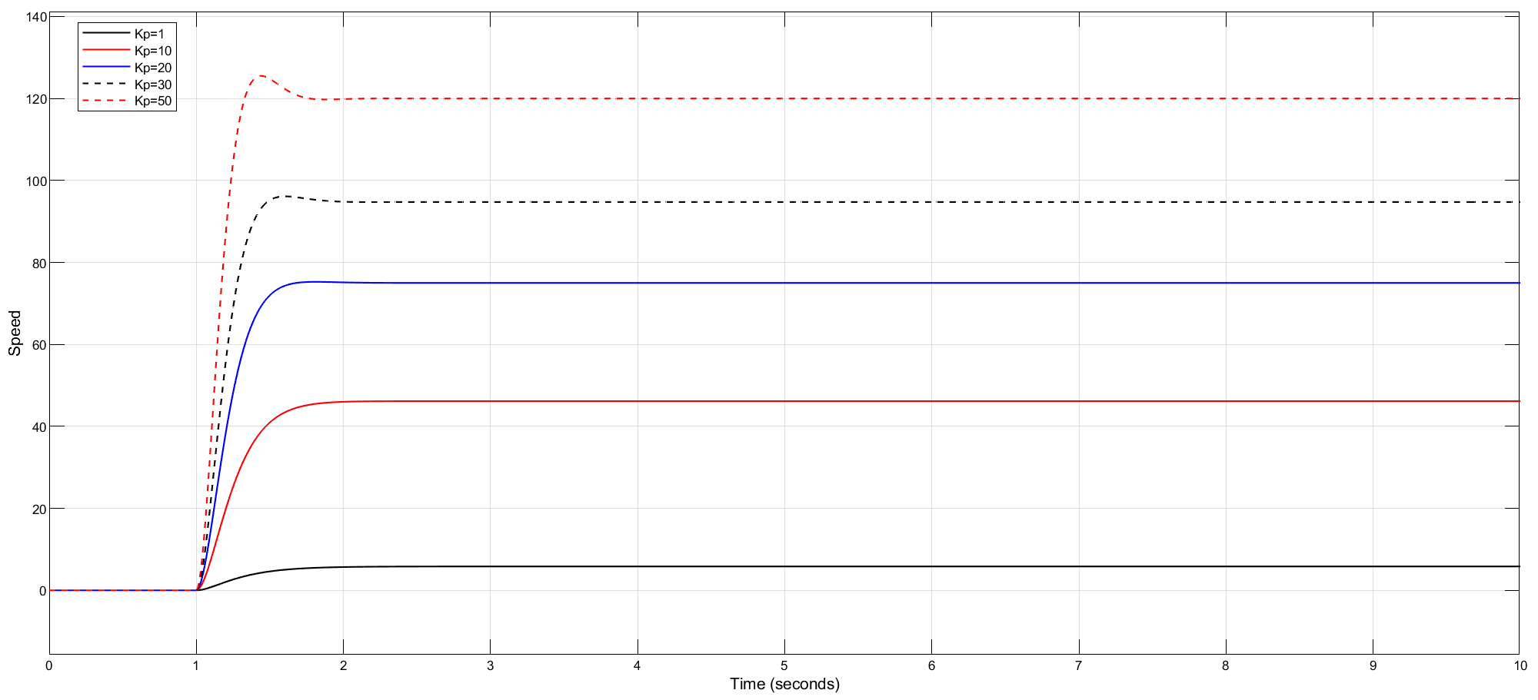

Figure : Investigate transfer function with varying Kp

In the P controller, when changing Kp, the steady-state time is reduced, there is no overshoot, and the steady-state error is reduced.

|  |  |  |  |  |  |
| --- | --- | --- | --- | --- | --- |
| Kp | 1 | 10 | 20 | 30 | 50 |
| Tr | 0.582 | 0.457 | 0.344 | 0.282 | 0.211 |
| σmax% | 0 | 0 | 0 | 0 | 0 |
| Exl | 194 | 154 | 125 | 105 | 80 |
| Txl | - | - | - | - | - |

### Surveying the system with PI controller ( kp = 33,323, kD = 0 ). Find the overshoot, steady-state error and transient time according to the following table

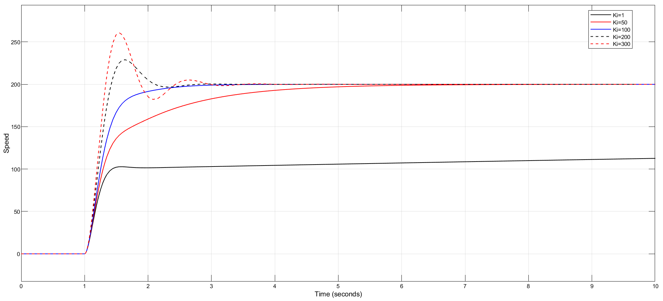

Figure : Investigate transfer function with varying Ki

|  |  |  |  |  |  |
| --- | --- | --- | --- | --- | --- |
| Ki | 1 | 50 | 100 | 200 | 300 |
| Tr | 0.277 | 1.69 | 0.534 | 0.284 | 0.222 |
| σmax% | 0 | 0 | 0 | 14.368 | 30.921 |
| Exl | 194 | 154 | 125 | 105 | 80 |
| Txl | - | 6 | 3 | 2.5 | 3.2 |

In the PI controller, when changing Ki, Kp remains the same, the rise time is not stable, the overshoot only occurs when Ki is sufficiently increased, the setting error decreases and the setting time changes.

# Exercises

* **Requirement**

Based on the system of space state equations in question 2.2a, use Simulink to describe the motor by HPT. Then replace the motor block described by the transfer function in the simulation diagram with the motor block described by HPT. And comment the result.

# Solution

## Exercise 1

Using Simulink to simulate the engine with space-state equation.

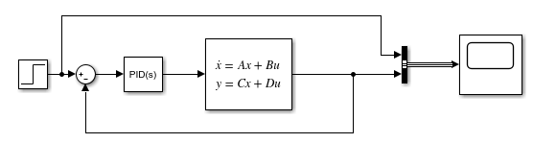

Figure : PID control block diagram with state space

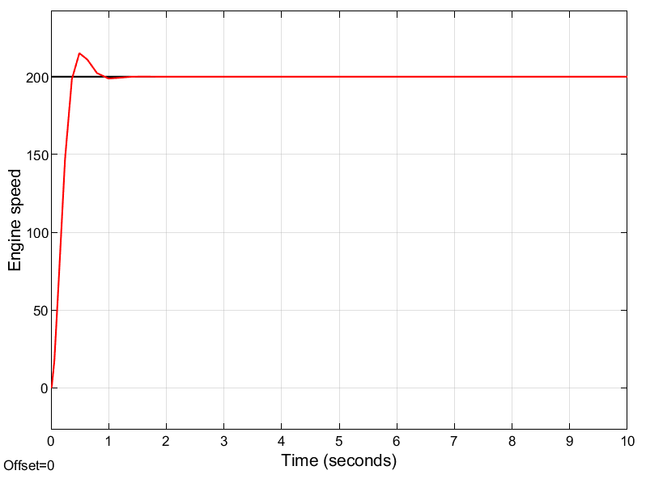

Figure : Output wave

### KI = 0, KD = 0 and Kp vary

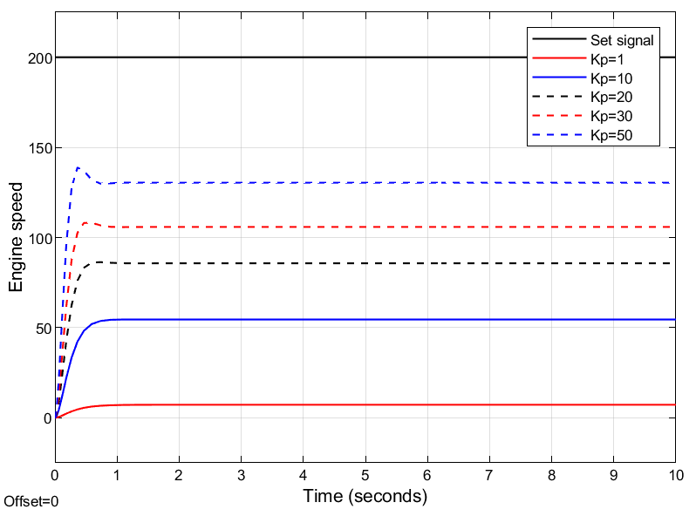

Figure : System output wave when changing Kp and Ki=0,Kd=0

Table : Parameters when changing Kp

|  |  |  |  |  |  |
| --- | --- | --- | --- | --- | --- |
| Kp | 1 | 10 | 20 | 30 | 50 |
| Tr (ms) | 588.974 | 415.608 | 318.850 | 259.135 | 193.464 |
| σmax% | 0.503 | 0.505 | 0.505 | 2.577 | 6.989 |
| exl | 192.775 | 145.48 | 114.31 | 94.1 | 69.6 |
| txl (s) | 1.062 | 0.703 | 0.499 | 0.609 | 0.567 |

Comment: when changing Kp over a wide range, then:

* POT: increase.
* Setting error: decrease.
* Set-up time: negligible change (slight decrease)
* Up Time: Decrease

- When Kp is increased, the steady-state error will decrease, so the response of the system will be improved.

- As Kp increases, the poles of the system will move away from the real, meaning the system will oscillate more and the overshoot will be larger.

- In case Kp is too large, the system will be less stable, if Kp is larger than Kgh, the system will be unstable.

### KP = 33,323, KD = 0

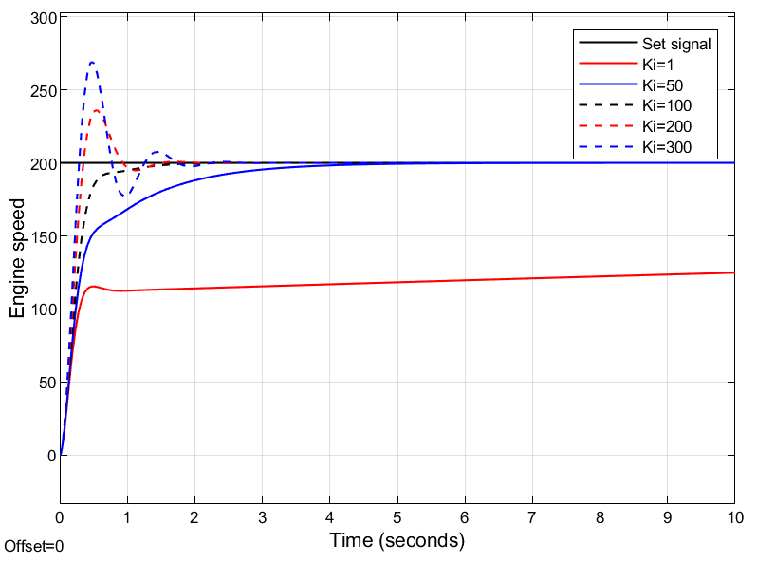

Figure : System output when changing Ki

Table : Parameter table when changing Ki

|  |  |  |  |  |  |
| --- | --- | --- | --- | --- | --- |
| KI | 1 | 50 | 100 | 200 | 300 |
| Tr (ms) | 244.159 | 1358 | 381.312 | 236.691 | 192.968 |
| σmax% | 2.259 | 0.457 | 0.311 | 18.452 | 34.459 |
| exl | 78.4 | 0.1 | 0 | 0 | 0 |
| txl (s) | 0.851 | 3.109 | 1.138 | 1.240 | 1.610 |

Comment: when KI increases from 1 to 300 (KP = 33.323; KD = 0):

* POT: increase.
* Setting error: rejected.
* Set-up time: increase.
* Up time: decrease.

- The integral stage participates in delaying transient response, increasing overshoot, reducing output setup error.

- Since the PI link is a special case of a phase delay corrector, it has the characteristics of a phase delay corrector. On the other hand, adding PI suture system is equivalent to adding 1 pole at the origin and 1 pole with negative real part → rootlocus is pushed to the right of the complex plane, so the system is less stable.

## Exercise 2

* Evaluation of DC motor under load.
* Evaluation of system quality in motor speed control model with load torque (Mc = 0.01) with PI controller designed without load torque.

### Solution.

When there is a load torque (Mc = 0.01) and from the formula we have in 4.3.2.2a, we have:





Matrix:





Substituting the numbers in, we have:





From formulas (1.32) and (1.33), simulate motor speed control with load Mc = 0.01.

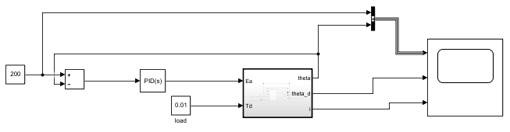

Figure : Block diagram of DC motor

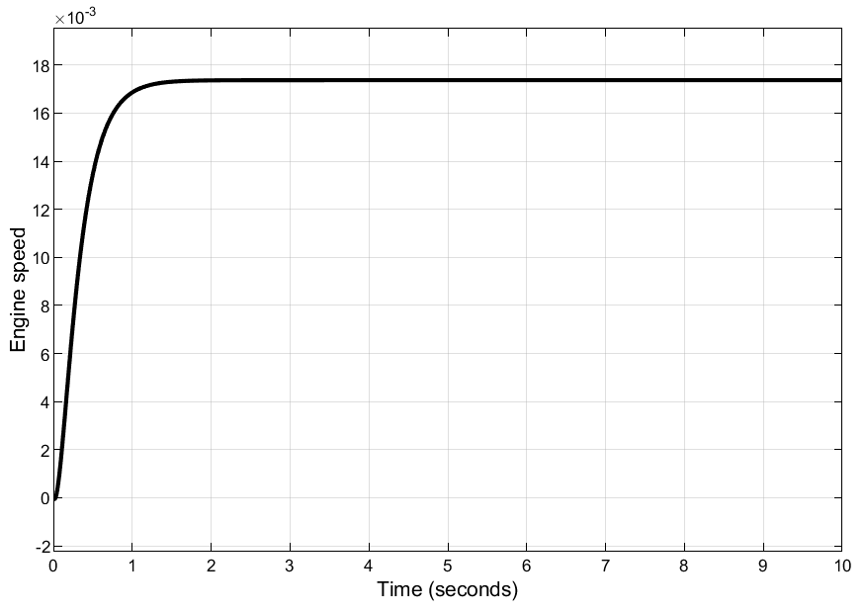

Figure : System output with Mc=0.01

* From Figure 8, we get overshoot of 0.503%, rise time of 590.584ms, steady state of 26.3, setting time of 1,089s.
* We can conclude that the PI controller does not correspond to the DC motor system when operating with a load Mc = 0.01.